Release Note FSA_iFiLE_Tool_1.0.73

For

Takaful Insurance Sector

**Contents**

**Introduction** 3

**Summary** 3

**Document Details** 4

**Release Note:** 5

**Taxonomy Modification Details** 8

**New Sheets Introduced** 8

**Sheets Omitted** 8

# **Introduction**

This release note document outlines the comprehensive taxonomy update for Takaful Insurance Sector, aligned with the International Financial Reporting Standard 17 (IFRS 17) requirements. The update represents a significant enhancement in financial reporting capabilities, introducing new detailed sheets and refining the existing reporting framework.

# **Summary**

The implementation of IFRS 17 has necessitated a fundamental transformation in how insurance and reinsurance companies report their financial information. Our taxonomy update is a direct response to these evolving regulatory requirements, ensuring comprehensive and transparent financial reporting.

This document will provide a comprehensive overview of the updated taxonomy, highlighting key changes and demonstrating its functionalities.

# **Document Details**

|  |  |
| --- | --- |
| **Date of deployment** | 20-July-2025 |
| **Type** | iFile Tool |
| **Version** | 1.0.73 |

**Pre-Release of iFile Excel Tool**:

This is the Excel-based desktop application used to generate the XBRL file for each sector:

* The latest version of this tool is applicable for all the entry points. Therefore, the different filters need not install different versions of the tool. This tool can be installed and used by all entities.

# **Release Note:**

Release Note:

1. Taxonomy has been updated for takaful insurance companies as per the IFRS 17 changes and AAOFI standards.

**Added sheets**

1. Statement of Cash flows, Indirect method

2. Statement of financial activities of the managed participant Takaful fund (PTF)

3. Statement of surplus and deficit in Participants Takaful Fund (PTF)

4. Statement of managed Participants Investment Fund (PIF)

5. Receivable from managed fund

6. Qard Hasan

7. Portfolio of takaful and re takaful arrangement

8.Takaful arrangement assets and liabilities

9. Takaful residual margin

10. Assets for takaful acquisition cash flow

11. Re takaful arrangement assets and liabilities

12. Investment income

13. Takaful revenue

14. Takaful costs

15. Income or expenses from re takaful arrangement

16. Wakala and Mudarib fee

**Deleted sheets**

1. Statement of Cash flows, Shareolders' Fund, Indirect Method
2. Statement of Cash Flows, Participants' Fund, Indirect Method
3. Statement of changes in Participants' Funds
4. Takaful and retakaful/reinsurance balance receivable
5. Takaful liabilities and retakaful contract assets
6. Claims and Provision for unearned contribution
7. Deferred policy acquisition Cost
8. Unearned retakaful commission

**Download link:**

Please find the link for downloading the iFile Excel Tool 1.0.73 -

<https://fsa.gov.om/Home/PublicPage/iFileExcel>

**FSA_Oman_iFile_Excel_Tool_1.0.73**: This zip file consists of the Installer to install on your system.

The link for the documentation and videos(illustrative) are as follows:

<https://fsa.gov.om/Home/XBRL/XBRLGuide>

**For any queries, please email to:**

1. xbrl@fsa.gov.om
2. cmaoman.support@irisbusiness.com

**Prerequisites for filing:**

1. **Check iFile Tool Version:** Please check your iFile tool version as shown on the screenshot below: If it is an older version then please use the latest ifile tool v.1.0.66.

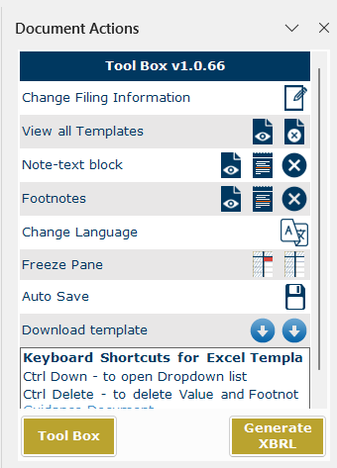

iFile Excel preparation tool Installation guide is available at <https://fsa.gov.om/Documents/XBRL/CMA%20Oman_iFile%20Excel%20Tool_Installation%20_Guide%20.docx.pdf>

1. To avoid mistakes while preparing your financial report on ifile excel tool kindly go through the frequently asked questions and basic business rules of ifile preparation tool from the below guidance document: <https://fsa.gov.om/Documents/XBRL/CMA%20Oman_iFile-FAQ_And_Business%20Rules_Guide.docx.pdf>
2. To avoid mismatch errors while uploading the XBRL zip file on XBRL portal, you can check your company profile details at the XBRL portal and prepare your financial reporting accordingly using the ifile tool. Please go through the following guidance document to know how to check your details at XBRL portal:

<https://fsa.gov.om/Documents/XBRL/CMA%20Oman_How%20To%20Check%20Company%20Details.pdf>